**ASSIGNMENT 2 REPORT**

**Name – Amol Dattatray Sangar**

**Username – asangar**

**Requirement:**

Make sure GCP SDK is installed along with GCP Beta SDK (for linking projects with billing account)

**Config File (config.yml):**

Contains initial values for network, firewall, server name, client name, zone and scripts path.

Modify the config file as you require.

**Operations performed in order:**

1. gcloud web authentication
2. Project creation/selection and then setting the current project to default configuration

Note – Make sure the project is already created and has a billing-account attached to it. There is no API to map a new project to billing account in GCP SDK and therefore the script doesn’t allow new project creation

1. API enabling – cloudresourcemanager and compute
2. VPC/Network creation
3. Firewall opening for tcp,udp,icmp and tcp:22,tcp:3389 ports
4. Two VM creation along with startup script (metadata.sh) for library installation
5. Waiting for startup scripts to finish on each VM
6. Server code Installation/Copying from local machine
7. Client code Installation/Copying from local machine
8. SSH into client and server VMs and unzipping code
9. Server startup
10. Client testing – performs 4 client tests
11. Copying server and client logs from VM to local machine
12. VM Shutdown/Stopping

**Run Script –**

* create.sh
* cleanup.sh

Resource cleanup – Deletes VM, Firewalls, and Network in that order

**Cost:**

**Virtual Machines**

* n1-standard-1 (1 vCPU, 3.75 GB memory) $0.04749975 per hour * 2

**Network**

* Ingress traffic No charge for ingress traffic
* Egress to the same Google Cloud zone when

using the internal IP addresses of the resources1 No charge

**Firewall**

* 500 or fewer attributes in the policy (standard) $1 per VM covered by the policy

There are two VMs which uses the firewall and hence it will cost $2 per month.

**VM Cost Estimator for the selected VMs -**

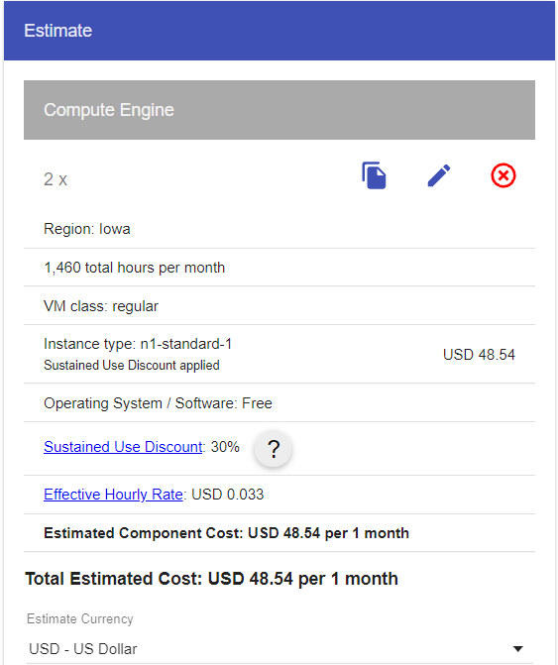

**Performance of key-value store when deployed to cloud VMs –**

All results can be found in the **output-logs folder** along with server logs after script execution

1. 100 simultaneous connections to server and closing them afterwards (CONNECTION TEST)

Test 1 Execution Time: 61743.148051 milliseconds

1. 100 connections to server and each perform 1 write and then 1 read

Test 2 Execution Time: 61758.51037199999 milliseconds

1. 1 client writes to 1 key every 0ms and another client reads from the same key every 0ms for 100 times (Performance + Concurrency test)

Test 3 Execution Time: 2175.790368999995 milliseconds

1. 2 clients write to same key at the same time for 500 times (Concurrency test for DB and multiple requests from a single client test)

Test 4 Execution Time: 4209.0177080000285 milliseconds